PRESS RELEASE

Best of both worlds: Koenig & Bauer Durst launches VariJET 106 in world premiere

- Exclusive live demonstrations provided for customers
- VariJET 106 combines the strengths of digital inkjet and classic offset printing together with inline finishing
- Beta testing for new B1 VariJET 106 single-pass digital press starting within weeks
Radebeul, Germany 15.10.2021
Koenig & Bauer Durst GmbH has unveiled the VariJET 106 in a world premiere with exclusive live demonstrations for customers and stakeholders in Radebeul, near Dresden, Germany, where the modular single pass sheetfed digital printing press for the folding carton market has been jointly developed by Koenig & Bauer and Durst.
Using market-proven industrial expertise from Durst and Koenig & Bauer, beta testing is due to start in the coming weeks. The first units of the VariJET 106 are due to be installed at customer sites in Europe and America in the second half of 2022. Target groups include pharmaceuticals, cosmetics, tobacco and food industries, as well as folding carton converters.
At the launch, which included presentations in the Customer Experience Center, senior executives unveiled further insights into Koenig & Bauer’s packaging strategy. Updates were provided on how the digitalization of business processes for new products and services is progressing.
The B1 5,500sph press combines the best of both worlds – digital inkjet and classic offset printing. The VariJET 106 is based on water-based inkjet processes to provide the highest print quality. The innovative digital printing system is at the heart of the collaborative development between Koenig & Bauer and Durst. The VariJET 106 platform is based on Koenig & Bauer’s standard high performance Rapida 106 platform and Durst printhead electronics, inkjet expertise and Durst workflow and RIP technology. This includes Durst Analytics, Smartshop and Workflow.
Using 7 color water-based food compliant inkjet technology (CMYK plus orange, green and violet), the VariJET 106 is suitable for food applications that meet the stringent requirements for food safe primary packaging utilizing proprietary water-based ink technology. The VariJET 106 can produce personalized and individualized print products or alternate between short and medium runs.
The VariJET 106 offers:
- Modular integration of upstream and downstream processes
- Combination of digital print with proven modules of the Rapida platform
- Perfect register accuracy thanks to inline production
- Highly competitive TCO, efficient production of ultra-short to medium runs
- Reduced resource consumption, storage costs and waste
- Absolute flexibility for test packaging and new campaigns
- Fastest possible response to market demands
Koenig & Bauer and Durst first announced they had joined forces and set up an independent joint venture company in 2019. The VariJET 106 is the first product jointly and developed by the two companies. Already in production and part of the Koenig & Bauer Durst portfolio are the Delta SPC 130 Series and the CorruJET 170 Series – aimed at corrugated packaging.
The VariJET 106, Delta SPC 130 and CorruJET 170 are designed with core technologies to provide automated, productive, food safe printing systems. They deliver shorter response times, more variants, shorter run lengths, individualization and enable more and more small value orders. They also answer the increasing customer demand for brand security, sustainability and the ability to meet brand owners’ requirements for multichannel communication including e-commerce.
Robert Stabler, Managing Director, Koenig & Bauer Durst, said: “This world premiere marks a proud moment – and what a journey it has been! We are really excited by the progress we have made and the opportunities with our VariJET 106 despite these testing times. We have beta sites at an advanced stage of planning. These potential customers already have a vision for mass customization will be working with us in partnership Feedback from our customers is that shorter run lengths, mass customization and the need to be more agile are the compelling reasons for moving to digital production.
“Successful companies need to be able to embrace the trends that are occurring and offer solutions. Brand owners continually want their products to stand out, require shorter lead times, while at the same time eliminate waste and conform to sustainability and track-and-trace requirements. Brand owners are also looking to ensure the new production methods are reliable, compliant and cost effective while converters need to have the capabilities and competencies to mass customize without any compromise on quality. We deliver on this.”

Image 1:

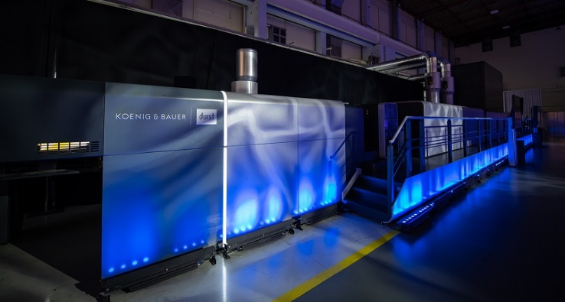

Spotlight on the long-awaited VariJET 106 at the premier in Radebeul

Image 2:

Robert Stabler, Managing Director, Koenig & Bauer Durst

Press contact
Further information from
Shaw Communications
Colin Harding
T +44 7730 435400
E colin.harding@shawcommunications.co.uk

About Koenig & Bauer Durst
Koenig & Bauer Durst is a young company in the digital printing systems market. The two parent companies Koenig & Bauer and Durst Group each hold 50 percent of the shares in the joint venture founded in 2019. The company develops, manufactures and markets single-pass digital printing presses for folding box and corrugated board production. It brings together the technological focus and market expertise of the two parent companies - both in the development of digital printing systems and in mechanical and plant engineering. The company is integrated into the service and sales structures of Koenig & Bauer and Durst Group and employs its own staff.

More information on www.koenig-bauer-durst.com

