Press Release

# Koenig & Bauer MetJET ONE Digital Press Shines During Successful Factory Acceptance Test

Koenig & Bauer MetalPrint and Reynolds Services, Inc. Revolutionise Metal Decoration with Digital Innovation

* Innovative metal packaging producer chooses a revolutionary new digital machine for its RSI Metal Litho plant in Greenville, PA and eagerly awaits first installation in the world
* Benefits of inkjet technology for industrial metal decoration ensure outstanding print quality and guarantee maximum flexibility in everyday production for metal applications.
* RSI will receive a customized solution that meets the high print quality requirements of its customers

Stuttgart, 03.12.2024

Koenig & Bauer MetalPrint, a global leader in metal decoration technology, and Reynolds Services, Inc., a leading provider of metal packaging solutions, have joined forces to usher in a new era of digital printing for metal.  
Koenig & Bauer MetalPrint has successfully developed the MetJET ONE, its fully integrated digital production line for metal decoration. This groundbreaking solution as a complete production line offers unparalleled flexibility and quality, enabling customers to produce highly customised metal packaging solutions with ease.

Reynolds Services, Inc. has embraced this technological advancement by selecting RSI Metal Litho Greenville as the site for the first installation of the MetJET ONE. This strategic decision enables Reynolds Services, Inc. to provide innovative, customized, and sustainable packaging solutions, even for very short production runs.  
After the successful factory acceptance test in Germany, the installation is scheduled for the first quarter of 2025 at the customer site. As part of the technology partnership agreement between Koenig & Bauer MetalPrint and Reynolds Services, the performance capability will be validated at the customer site and put through its paces during an initial test phase under real operating conditions..

“We were delighted to accompany the Koenig & Bauer MetalPrint team to witness the factory test in Stuttgart, Germany, in late October and see our new MetJET ONE digital press perform flawlessly,” explains John Frangakis, CEO at Reynolds Services, Inc. “We chose the MetJET ONE to gain exceptional benefits such as outstanding digital print quality, appealing price-performance ratio, and modular and customizable line configuration. This digital printing solution will allow our customers to order customized solutions in very short runs.”

In early November, Koenig & Bauer MetalPrint customers and press representatives had the opportunity to see the first MetJET ONE in action in Stuttgart, Germany. The cutting-edge technology and outstanding quality impressed the participants as much as John Frangakis, who explained:”

"Metal packaging is the most sustainable and durable option for consumer packaging,” says Frangakis. “One of the biggest challenges we've faced in the metal packaging industry has been addressing the increasing demand from retailers and customers for small, customized production runs with quick turnarounds. With the introduction of digital printing technology through Koenig & Bauer's MetJET ONE, we can now meet these demands more efficiently. What was once cost-prohibitive or impractical is now achievable, opening new opportunities for growth and innovation in the metal packaging market."

The MetJET ONE merges Koenig & Bauer MetalPrint's expertise in sheet handling and system engineering with Durst's cutting-edge inkjet technology, offering a fully customisable solution. Designed to adapt to the evolving needs of the metal packaging industry, it provides unparalleled flexibility in configuration to meet diverse customer requirements.

"The MetJET ONE redefines the standards in metal decoration with its attractive price-performance ratio and outstanding print quality combined with its flexible line-design." said Ralf Hipp, CEO of Koenig & Bauer MetalPrint.

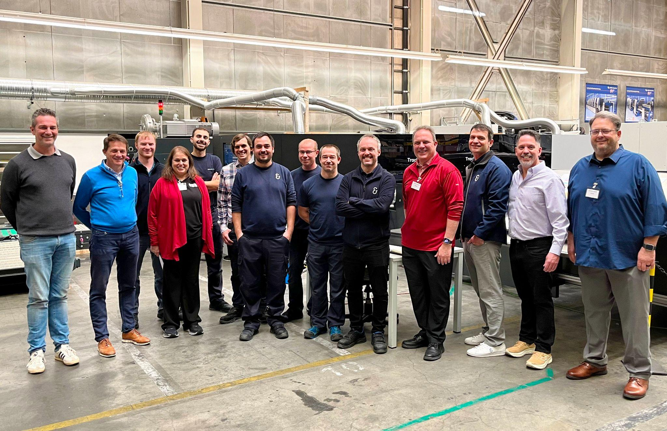

#### 

#### Photo:

John Frangakis, CEO at Reynolds Services, Inc., and the RSI team of RSI Metal Litho Greenville, were thrilled to see their Koenig & Bauer MetJET ONE, the first digital printing press in a production line for metal decorating, in action at Koenig & Bauer’s facility in Stuttgart, Germany

#### 

#### Contact person for the press Koenig & Bauer MetalPrint Simone Schwebsch +49 711 69971-847 simone.schwebsch@koenig-bauer.com

**About Koenig & Bauer**Koenig & Bauer is a globally active printing press manufacturer headquartered in Würzburg (Germany). It supplies machines and software solutions covering the entire printing, finishing and converting process, with a particular focus on packaging. Machines from Koenig & Bauer are capable of printing on practically all substrates – the portfolio ranges from banknotes to board, corrugated, film, metal and glass packaging, and includes book, display, coding, decor, magazine, advertising and newspaper printing. With a history extending back more than 200 years, Koenig & Bauer is the oldest printing press manufacturer in the world and is today at home in virtually all printing processes. Together, the group companies count a total of around 5,700 employees. Koenig & Bauer operates manufacturing plants at eleven locations in Europe, alongside a global sales and service network. The annual revenue in the 2023 financial year was around €1.3bn.

Further information can be found at [www.koenig-bauer.com](http://www.koenig-bauer.com/)